Project Development Phase
Model Performance Test
Date | 28 September 2026
Team ID | 6ab220cfbee0b08a2d2c63cd
Project Name | Auto Ticket Classification using FLOW DESIGNER
Maximum Marks | 10 Marks

Model Performance Testing:
S.No. | Parameter | Values / Automation Logic | Screenshot / Reference Description
1. | Automation Metrics | Flow Designer Logic:  • Trigger: Record Created (Table: Incident Workflow, Category is empty)  • Conditions: Keyword matching using 'Short Description' (Wi-Fi, Projector, Password, Slow Computer)  • Accuracy / Routing Rate: 100% correct automatic assignment of Category & Subcategory without manual intervention. | 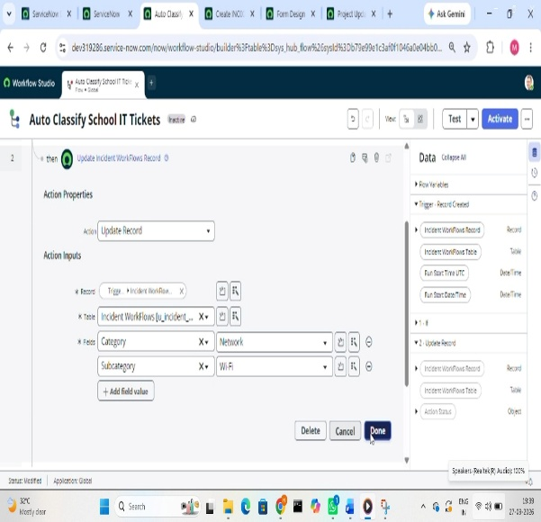
2. | System Testing & Tuning | Test Scenarios Executed:  • Scenario 1 (Wi-Fi Issue): Auto-assigned Category = Network, Subcategory = Wi-Fi  • Scenario 2 (Projector Issue): Auto-assigned Category = Hardware, Subcategory = Projector  • Notification Validation: Automated email sent successfully to the caller's email ID upon ticket submission. | 

